Appendix Table 1.
Clopper Pearson Exact 95% Confidence Intervals for a Single Proportion (0.1 to 0.9 by 0.1)
Sample size (n) | p | Lower Confidence Limit | Upper Confidence Limit | Width of CI
10 | 0.1 | 0.003 | 0.445 | 0.442
10 | 0.2 | 0.025 | 0.556 | 0.531
10 | 0.3 | 0.067 | 0.652 | 0.586
10 | 0.4 | 0.122 | 0.738 | 0.616
10 | 0.5 | 0.187 | 0.813 | 0.626
10 | 0.6 | 0.262 | 0.878 | 0.616
10 | 0.7 | 0.348 | 0.933 | 0.586
10 | 0.8 | 0.444 | 0.975 | 0.531
10 | 0.9 | 0.555 | 0.997 | 0.442
20 | 0.1 | 0.012 | 0.317 | 0.305
20 | 0.2 | 0.057 | 0.437 | 0.379
20 | 0.3 | 0.119 | 0.543 | 0.424
20 | 0.4 | 0.191 | 0.639 | 0.448
20 | 0.5 | 0.272 | 0.728 | 0.456
20 | 0.6 | 0.361 | 0.809 | 0.448
20 | 0.7 | 0.457 | 0.881 | 0.424
20 | 0.8 | 0.563 | 0.943 | 0.379
20 | 0.9 | 0.683 | 0.988 | 0.305
30 | 0.1 | 0.021 | 0.265 | 0.244
30 | 0.2 | 0.077 | 0.386 | 0.309
30 | 0.3 | 0.147 | 0.494 | 0.347
30 | 0.4 | 0.227 | 0.594 | 0.367
30 | 0.5 | 0.313 | 0.687 | 0.374
30 | 0.6 | 0.406 | 0.773 | 0.367
30 | 0.7 | 0.506 | 0.853 | 0.347
30 | 0.8 | 0.614 | 0.923 | 0.309
30 | 0.9 | 0.735 | 0.979 | 0.244
40 | 0.1 | 0.028 | 0.237 | 0.209
40 | 0.2 | 0.091 | 0.356 | 0.266
40 | 0.3 | 0.166 | 0.465 | 0.300
40 | 0.4 | 0.249 | 0.567 | 0.318
40 | 0.5 | 0.338 | 0.662 | 0.324
40 | 0.6 | 0.433 | 0.751 | 0.318
40 | 0.7 | 0.535 | 0.834 | 0.300
40 | 0.8 | 0.644 | 0.909 | 0.266
40 | 0.9 | 0.763 | 0.972 | 0.209
50 | 0.1 | 0.033 | 0.218 | 0.185
50 | 0.2 | 0.100 | 0.337 | 0.237
50 | 0.3 | 0.179 | 0.446 | 0.267
50 | 0.4 | 0.264 | 0.548 | 0.284
50 | 0.5 | 0.355 | 0.645 | 0.289
50 | 0.6 | 0.452 | 0.736 | 0.284
50 | 0.7 | 0.554 | 0.821 | 0.267
50 | 0.8 | 0.663 | 0.900 | 0.237
50 | 0.9 | 0.782 | 0.967 | 0.185
60 | 0.1 | 0.038 | 0.205 | 0.167
60 | 0.2 | 0.108 | 0.323 | 0.215
60 | 0.3 | 0.188 | 0.432 | 0.244
60 | 0.4 | 0.276 | 0.535 | 0.259
60 | 0.5 | 0.368 | 0.632 | 0.264
60 | 0.6 | 0.465 | 0.724 | 0.259
60 | 0.7 | 0.568 | 0.812 | 0.244
60 | 0.8 | 0.677 | 0.892 | 0.215
60 | 0.9 | 0.795 | 0.962 | 0.167
70 | 0.1 | 0.041 | 0.195 | 0.154
70 | 0.2 | 0.114 | 0.313 | 0.199
70 | 0.3 | 0.196 | 0.421 | 0.225
70 | 0.4 | 0.285 | 0.524 | 0.239
70 | 0.5 | 0.378 | 0.622 | 0.244
70 | 0.6 | 0.476 | 0.715 | 0.239
70 | 0.7 | 0.579 | 0.804 | 0.225
70 | 0.8 | 0.687 | 0.886 | 0.199
70 | 0.9 | 0.805 | 0.959 | 0.154
80 | 0.1 | 0.044 | 0.188 | 0.143
80 | 0.2 | 0.119 | 0.304 | 0.186
80 | 0.3 | 0.203 | 0.413 | 0.210
80 | 0.4 | 0.292 | 0.516 | 0.224
80 | 0.5 | 0.386 | 0.614 | 0.228
80 | 0.6 | 0.484 | 0.708 | 0.224
80 | 0.7 | 0.587 | 0.797 | 0.210
80 | 0.8 | 0.696 | 0.881 | 0.186
80 | 0.9 | 0.812 | 0.956 | 0.143
90 | 0.1 | 0.047 | 0.181 | 0.135
90 | 0.2 | 0.123 | 0.298 | 0.174
90 | 0.3 | 0.208 | 0.406 | 0.198
90 | 0.4 | 0.298 | 0.509 | 0.211
90 | 0.5 | 0.393 | 0.607 | 0.215
90 | 0.6 | 0.491 | 0.702 | 0.211
90 | 0.7 | 0.594 | 0.792 | 0.198
90 | 0.8 | 0.702 | 0.877 | 0.174
90 | 0.9 | 0.819 | 0.953 | 0.135
Note: There are no rules of thumb for CI width magnitude. Interpretation depends in part on the proportion; if it is close to 0.1 or 0.9, the absolute width is not that large, but is still quite variable around the point estimate. At 0.5, the width is maximal; for example, given a sample size of 70 and point estimate 0.50, the 95% CI is (0.378, 0.622) with width 0.244. This value may be considered acceptable, but larger than desired.

Appendix Table 2
95% Confidence Intervals (Wald Method with Continuity Correction) for Difference in two Proportions
p2 - p1 = d (p1=0.1, 0.2, 0.3, 0.4, d=0.1, 0.2, 0.3) n = Sample Size per Group
N | d | p1 | p2 | Lower Confidence Limit | Upper Confidence Limit | Width of CI
10 | 0.1 | 0.1 | 0.2 | -0.310 | 0.510 | 0.820
10 | 0.1 | 0.2 | 0.3 | -0.377 | 0.577 | 0.954
10 | 0.1 | 0.3 | 0.4 | -0.416 | 0.616 | 1.032
10 | 0.1 | 0.4 | 0.5 | -0.434 | 0.634 | 1.068
10 | 0.2 | 0.1 | 0.3 | -0.239 | 0.639 | 0.879
10 | 0.2 | 0.2 | 0.4 | -0.292 | 0.692 | 0.984
10 | 0.2 | 0.3 | 0.5 | -0.320 | 0.720 | 1.041
10 | 0.2 | 0.4 | 0.6 | -0.329 | 0.729 | 1.059
10 | 0.3 | 0.1 | 0.4 | -0.156 | 0.756 | 0.912
10 | 0.3 | 0.2 | 0.5 | -0.197 | 0.797 | 0.994
10 | 0.3 | 0.3 | 0.6 | -0.216 | 0.816 | 1.032
10 | 0.3 | 0.4 | 0.7 | -0.216 | 0.816 | 1.032
20 | 0.1 | 0.1 | 0.2 | -0.169 | 0.369 | 0.538
20 | 0.1 | 0.2 | 0.3 | -0.217 | 0.417 | 0.633
20 | 0.1 | 0.3 | 0.4 | -0.244 | 0.444 | 0.688
20 | 0.1 | 0.4 | 0.5 | -0.257 | 0.457 | 0.714
20 | 0.2 | 0.1 | 0.3 | -0.090 | 0.490 | 0.580
20 | 0.2 | 0.2 | 0.4 | -0.127 | 0.527 | 0.654
20 | 0.2 | 0.3 | 0.5 | -0.147 | 0.547 | 0.694
20 | 0.2 | 0.4 | 0.6 | -0.154 | 0.554 | 0.707
20 | 0.3 | 0.1 | 0.4 | -0.002 | 0.602 | 0.604
20 | 0.3 | 0.2 | 0.5 | -0.031 | 0.631 | 0.661
20 | 0.3 | 0.3 | 0.6 | -0.044 | 0.644 | 0.688
20 | 0.3 | 0.4 | 0.7 | -0.044 | 0.644 | 0.688
30 | 0.1 | 0.1 | 0.2 | -0.112 | 0.312 | 0.425
30 | 0.1 | 0.2 | 0.3 | -0.151 | 0.351 | 0.502
30 | 0.1 | 0.3 | 0.4 | -0.173 | 0.373 | 0.547
30 | 0.1 | 0.4 | 0.5 | -0.184 | 0.384 | 0.568
30 | 0.2 | 0.1 | 0.3 | -0.029 | 0.429 | 0.459
30 | 0.2 | 0.2 | 0.4 | -0.060 | 0.460 | 0.519
30 | 0.2 | 0.3 | 0.5 | -0.076 | 0.476 | 0.552
30 | 0.2 | 0.4 | 0.6 | -0.081 | 0.481 | 0.563
30 | 0.3 | 0.1 | 0.4 | 0.061 | 0.539 | 0.478
30 | 0.3 | 0.2 | 0.5 | 0.038 | 0.562 | 0.525
30 | 0.3 | 0.3 | 0.6 | 0.027 | 0.573 | 0.547
30 | 0.3 | 0.4 | 0.7 | 0.027 | 0.573 | 0.547
40 | 0.1 | 0.1 | 0.2 | -0.080 | 0.280 | 0.360
40 | 0.1 | 0.2 | 0.3 | -0.114 | 0.314 | 0.427
40 | 0.1 | 0.3 | 0.4 | -0.133 | 0.333 | 0.466
40 | 0.1 | 0.4 | 0.5 | -0.142 | 0.342 | 0.484
40 | 0.2 | 0.1 | 0.3 | 0.005 | 0.395 | 0.389
40 | 0.2 | 0.2 | 0.4 | -0.021 | 0.421 | 0.442
40 | 0.2 | 0.3 | 0.5 | -0.035 | 0.435 | 0.470
40 | 0.2 | 0.4 | 0.6 | -0.040 | 0.440 | 0.479
40 | 0.3 | 0.1 | 0.4 | 0.097 | 0.503 | 0.406
40 | 0.3 | 0.2 | 0.5 | 0.077 | 0.523 | 0.447
40 | 0.3 | 0.3 | 0.6 | 0.067 | 0.533 | 0.466
40 | 0.3 | 0.4 | 0.7 | 0.067 | 0.533 | 0.466
50 | 0.1 | 0.1 | 0.2 | -0.059 | 0.259 | 0.317
50 | 0.1 | 0.2 | 0.3 | -0.089 | 0.289 | 0.377
50 | 0.1 | 0.3 | 0.4 | -0.106 | 0.306 | 0.412
50 | 0.1 | 0.4 | 0.5 | -0.114 | 0.314 | 0.428
50 | 0.2 | 0.1 | 0.3 | 0.028 | 0.372 | 0.344
50 | 0.2 | 0.2 | 0.4 | 0.005 | 0.395 | 0.391
50 | 0.2 | 0.3 | 0.5 | -0.008 | 0.408 | 0.416
50 | 0.2 | 0.4 | 0.6 | -0.012 | 0.412 | 0.424
50 | 0.3 | 0.1 | 0.4 | 0.121 | 0.479 | 0.358
50 | 0.3 | 0.2 | 0.5 | 0.103 | 0.497 | 0.395
50 | 0.3 | 0.3 | 0.6 | 0.094 | 0.506 | 0.412
50 | 0.3 | 0.4 | 0.7 | 0.094 | 0.506 | 0.412
60 | 0.1 | 0.1 | 0.2 | -0.043 | 0.243 | 0.286
60 | 0.1 | 0.2 | 0.3 | -0.071 | 0.271 | 0.341
60 | 0.1 | 0.3 | 0.4 | -0.086 | 0.286 | 0.373
60 | 0.1 | 0.4 | 0.5 | -0.094 | 0.294 | 0.388
60 | 0.2 | 0.1 | 0.3 | 0.045 | 0.355 | 0.311
60 | 0.2 | 0.2 | 0.4 | 0.023 | 0.377 | 0.353
60 | 0.2 | 0.3 | 0.5 | 0.012 | 0.388 | 0.377
60 | 0.2 | 0.4 | 0.6 | 0.008 | 0.392 | 0.384
60 | 0.3 | 0.1 | 0.4 | 0.138 | 0.462 | 0.324
60 | 0.3 | 0.2 | 0.5 | 0.121 | 0.479 | 0.357
60 | 0.3 | 0.3 | 0.6 | 0.114 | 0.486 | 0.373
60 | 0.3 | 0.4 | 0.7 | 0.114 | 0.486 | 0.373
70 | 0.1 | 0.1 | 0.2 | -0.031 | 0.231 | 0.263
70 | 0.1 | 0.2 | 0.3 | -0.057 | 0.257 | 0.314
70 | 0.1 | 0.3 | 0.4 | -0.071 | 0.271 | 0.343
70 | 0.1 | 0.4 | 0.5 | -0.078 | 0.278 | 0.357
70 | 0.2 | 0.1 | 0.3 | 0.057 | 0.343 | 0.285
70 | 0.2 | 0.2 | 0.4 | 0.038 | 0.362 | 0.325
70 | 0.2 | 0.3 | 0.5 | 0.027 | 0.373 | 0.346
70 | 0.2 | 0.4 | 0.6 | 0.023 | 0.377 | 0.353
70 | 0.3 | 0.1 | 0.4 | 0.151 | 0.449 | 0.298
70 | 0.3 | 0.2 | 0.5 | 0.136 | 0.464 | 0.329
70 | 0.3 | 0.3 | 0.6 | 0.129 | 0.471 | 0.343
70 | 0.3 | 0.4 | 0.7 | 0.129 | 0.471 | 0.343
80 | 0.1 | 0.1 | 0.2 | -0.022 | 0.222 | 0.244
80 | 0.1 | 0.2 | 0.3 | -0.046 | 0.246 | 0.292
80 | 0.1 | 0.3 | 0.4 | -0.059 | 0.259 | 0.319
80 | 0.1 | 0.4 | 0.5 | -0.066 | 0.266 | 0.332
80 | 0.2 | 0.1 | 0.3 | 0.067 | 0.333 | 0.265
80 | 0.2 | 0.2 | 0.4 | 0.049 | 0.351 | 0.302
80 | 0.2 | 0.3 | 0.5 | 0.039 | 0.361 | 0.322
80 | 0.2 | 0.4 | 0.6 | 0.036 | 0.364 | 0.329
80 | 0.3 | 0.1 | 0.4 | 0.162 | 0.438 | 0.277
80 | 0.3 | 0.2 | 0.5 | 0.147 | 0.453 | 0.306
80 | 0.3 | 0.3 | 0.6 | 0.141 | 0.459 | 0.319
80 | 0.3 | 0.4 | 0.7 | 0.141 | 0.459 | 0.319
90 | 0.1 | 0.1 | 0.2 | -0.014 | 0.214 | 0.229
90 | 0.1 | 0.2 | 0.3 | -0.037 | 0.237 | 0.274
90 | 0.1 | 0.3 | 0.4 | -0.050 | 0.250 | 0.299
90 | 0.1 | 0.4 | 0.5 | -0.056 | 0.256 | 0.311
90 | 0.2 | 0.1 | 0.3 | 0.076 | 0.324 | 0.249
90 | 0.2 | 0.2 | 0.4 | 0.058 | 0.342 | 0.284
90 | 0.2 | 0.3 | 0.5 | 0.049 | 0.351 | 0.302
90 | 0.2 | 0.4 | 0.6 | 0.046 | 0.354 | 0.308
90 | 0.3 | 0.1 | 0.4 | 0.170 | 0.430 | 0.260
90 | 0.3 | 0.2 | 0.5 | 0.157 | 0.443 | 0.287
90 | 0.3 | 0.3 | 0.6 | 0.150 | 0.450 | 0.299
90 | 0.3 | 0.4 | 0.7 | 0.150 | 0.450 | 0.299

Appendix Figure 1. Clopper Pearson Exact 95% Confidence Intervals for a Single Proportion
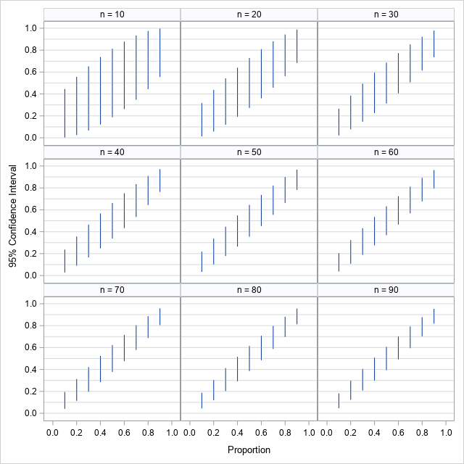

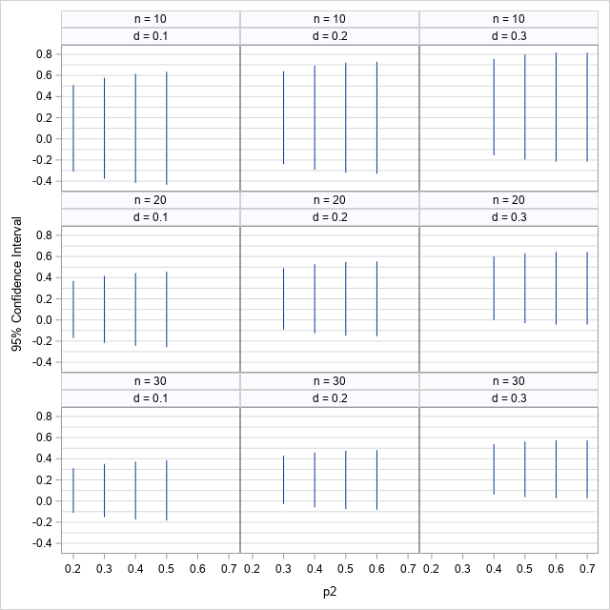
Appendix Figure 2. 95% Confidence Intervals (Wald Method with Continuity Correction) for Difference in 2 Proportions

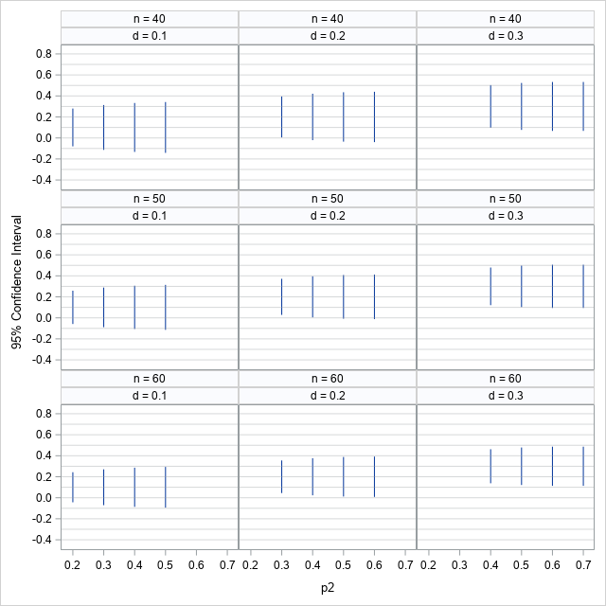
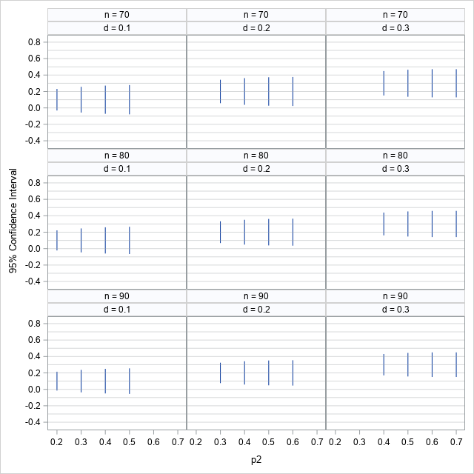
p2 - p1 = d (p1=0.1, 0.2, 0.3, 0.4)
n = Sample size per group

Appendix Figure 3. 95% Confidence Intervals for Pearson Correlation Coefficient
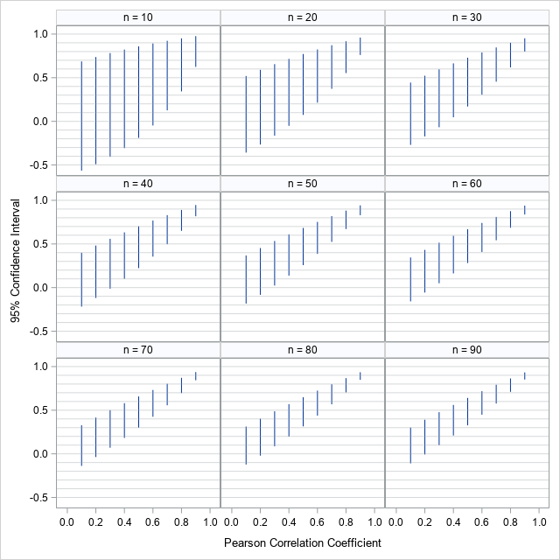

Appendix Table 3
95% Confidence Intervals for Pearson Correlation Coefficient (0.1 to 0.9 by 0.1)
n | r | Lower Confidence Limit | Upper Confidence Limit | Width of CI
10 | 0.1 | -0.565 | 0.686 | 1.252
10 | 0.2 | -0.492 | 0.737 | 1.228
10 | 0.3 | -0.406 | 0.782 | 1.188
10 | 0.4 | -0.307 | 0.822 | 1.129
10 | 0.5 | -0.189 | 0.859 | 1.048
10 | 0.6 | -0.048 | 0.892 | 0.940
10 | 0.7 | 0.126 | 0.923 | 0.797
10 | 0.8 | 0.343 | 0.951 | 0.607
10 | 0.9 | 0.624 | 0.976 | 0.352
20 | 0.1 | -0.358 | 0.520 | 0.878
20 | 0.2 | -0.266 | 0.590 | 0.856
20 | 0.3 | -0.164 | 0.656 | 0.820
20 | 0.4 | -0.052 | 0.716 | 0.767
20 | 0.5 | 0.074 | 0.772 | 0.698
20 | 0.6 | 0.214 | 0.824 | 0.609
20 | 0.7 | 0.373 | 0.872 | 0.499
20 | 0.8 | 0.553 | 0.918 | 0.364
20 | 0.9 | 0.760 | 0.960 | 0.200
30 | 0.1 | -0.270 | 0.444 | 0.714
30 | 0.2 | -0.173 | 0.523 | 0.695
30 | 0.3 | -0.068 | 0.596 | 0.663
30 | 0.4 | 0.046 | 0.665 | 0.618
30 | 0.5 | 0.170 | 0.729 | 0.559
30 | 0.6 | 0.306 | 0.790 | 0.484
30 | 0.7 | 0.454 | 0.847 | 0.392
30 | 0.8 | 0.618 | 0.901 | 0.283
30 | 0.9 | 0.799 | 0.952 | 0.153
40 | 0.1 | -0.218 | 0.399 | 0.617
40 | 0.2 | -0.119 | 0.482 | 0.600
40 | 0.3 | -0.013 | 0.559 | 0.572
40 | 0.4 | 0.101 | 0.633 | 0.532
40 | 0.5 | 0.223 | 0.702 | 0.479
40 | 0.6 | 0.355 | 0.768 | 0.413
40 | 0.7 | 0.497 | 0.830 | 0.334
40 | 0.8 | 0.651 | 0.890 | 0.239
40 | 0.9 | 0.818 | 0.946 | 0.128
50 | 0.1 | -0.183 | 0.368 | 0.552
50 | 0.2 | -0.083 | 0.453 | 0.536
50 | 0.3 | 0.024 | 0.534 | 0.510
50 | 0.4 | 0.137 | 0.610 | 0.474
50 | 0.5 | 0.257 | 0.683 | 0.426
50 | 0.6 | 0.386 | 0.753 | 0.367
50 | 0.7 | 0.524 | 0.819 | 0.295
50 | 0.8 | 0.671 | 0.882 | 0.211
50 | 0.9 | 0.829 | 0.942 | 0.113
60 | 0.1 | -0.158 | 0.345 | 0.503
60 | 0.2 | -0.057 | 0.432 | 0.489
60 | 0.3 | 0.050 | 0.515 | 0.465
60 | 0.4 | 0.163 | 0.594 | 0.431
60 | 0.5 | 0.282 | 0.669 | 0.387
60 | 0.6 | 0.408 | 0.741 | 0.333
60 | 0.7 | 0.543 | 0.810 | 0.267
60 | 0.8 | 0.685 | 0.876 | 0.191
60 | 0.9 | 0.837 | 0.939 | 0.102
70 | 0.1 | -0.138 | 0.327 | 0.466
70 | 0.2 | -0.037 | 0.415 | 0.452
70 | 0.3 | 0.070 | 0.500 | 0.430
70 | 0.4 | 0.182 | 0.580 | 0.398
70 | 0.5 | 0.300 | 0.658 | 0.357
70 | 0.6 | 0.425 | 0.732 | 0.307
70 | 0.7 | 0.557 | 0.803 | 0.246
70 | 0.8 | 0.696 | 0.871 | 0.175
70 | 0.9 | 0.843 | 0.937 | 0.093
80 | 0.1 | -0.122 | 0.313 | 0.435
80 | 0.2 | -0.021 | 0.402 | 0.423
80 | 0.3 | 0.086 | 0.488 | 0.402
80 | 0.4 | 0.198 | 0.570 | 0.372
80 | 0.5 | 0.315 | 0.648 | 0.334
80 | 0.6 | 0.438 | 0.724 | 0.286
80 | 0.7 | 0.568 | 0.797 | 0.230
80 | 0.8 | 0.704 | 0.867 | 0.163
80 | 0.9 | 0.848 | 0.935 | 0.087
90 | 0.1 | -0.109 | 0.301 | 0.410
90 | 0.2 | -0.007 | 0.391 | 0.398
90 | 0.3 | 0.099 | 0.477 | 0.378
90 | 0.4 | 0.210 | 0.561 | 0.350
90 | 0.5 | 0.327 | 0.641 | 0.314
90 | 0.6 | 0.449 | 0.718 | 0.269
90 | 0.7 | 0.576 | 0.792 | 0.216
90 | 0.8 | 0.711 | 0.864 | 0.153
90 | 0.9 | 0.852 | 0.933 | 0.082
Notes: The 95% CI on the original scale is not symmetric; instead of reporting SE, the 95% CI itself should be reported.

